

Europass  Curriculum Vitae |  | 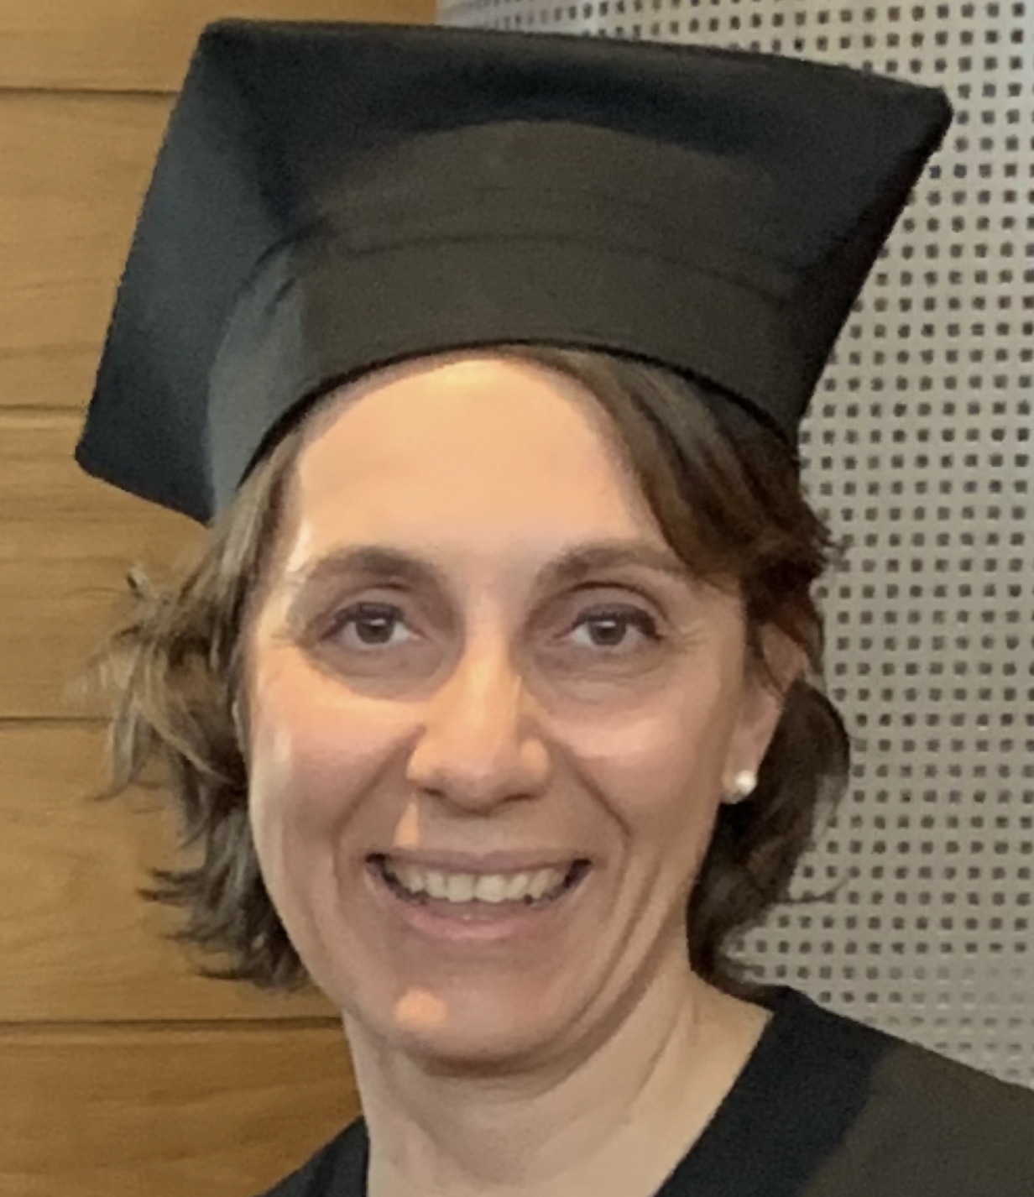
Personal information
First name(s) / Surname(s) |  | Francesca Visintin
Address |  | Via Tomadini 30/a 33100 Udine Italy
Telephone |  | ( 0432249336 )
E-mail |  | ( francesca.visintin@uniud.it )
Work experience
Dates |  | Since 2022
University of Udine
Role |  | Research deputy in the Department of Economics and Statistics
Dates |  | Since 2018
University of Udine
SSD  Role |  | Secs p10  Full professor of Organization studies
Dates |  | Since 2016
University of Udine
Role |  | Director of the master in Hr management
Dates |  | 2012-2020
University of Udine
Role |  | Coordinator of the PhD MAS University of Udine and University of Trieste
Dates |  | 2009-2018
University of Udine
Role |  | Associate professor in Organisation studies.
Dates |  | 2007-2009
University of Udine
Role |  | Researcher in Organisation studies.
Dates |  | 2002-2003
University of Udine
Role |  | Post doc on the subject of "Ict and organisational change", at the University of Udine.
D
Education and training
Dates |  | 1998-2001
Title of qualification awarded |  | PhD in Management, economics and politics, University of St.Andrews (Scotland) with a thesis entitled: Corporate governance and innovation in the machine tools sector in Italy. Supervisor: Prof. Gavin Reid, University of St.Andrews; Discussant: Prof. Stan Metcalfe, University of Manchester.
Dates |  | 1997-1998
Title of qualification awarded |  | Master (M.Litt) in Management, economics and politics, University of St.Andrews (Scotland) with a thesis entitled: The Italian public debt: a political issue. Supervisor: Prof. David Cobham.
Dates |  | 1991-1996
Title of qualification awarded |  | Degree in Economics, University of Udine with a thesis entitled: La funzione finanziaria nei gruppi di imprese. Supervisor: Prof. Luciano Pilotti.
Personal skills and competences
Mother tongue |  | Italian
Other language
Self-assessment |  |  | Understanding |  |  |  |  | Speaking |  |  |  |  | Writing
European level (*) |  |  | Listening |  | Reading |  |  | Spoken interaction |  | Spoken production
English |  |  |  | C1 |  | C1 |  |  | C1 |  |  | C1 |  | C1
 |  | (*) Common European Framework of Reference for Languages
Research projects and/or groups |  | 2018-2021: Local unit coordinator in Udine as part of the Interreg Italy-Austria project SIAA, Social Impact for the Alps Adriatic Region.  2012-2015: National scientific coordinator of a Prin 2010 project entitled: Scientific research and competitiveness. Variety of enterprise forms, support systems and performance dimensions. The project involved 10 other Italian universities and produced several articles in international journals, a database on 1000 enterprises, 66 case studies, and an editorship with Edward Elgar: Visintin F., Pittino D., (eds): Fast Growing Firms in a Slow Growth Economy. Total funding: approximately EUR 850,000.  Since 2012: entrusted by the Regional Employment Agency with the drafting of the "White Paper on Technological Innovation in Friuli Venezia Giulia".  2010-2012: Scientific Responsible for the management and organisation area of the project: "Le reti di imprese: uno studio della provincia di Udine", funded by the Udine Chamber of Commerce. The research involves a scientific study on a sample basis (700 enterprises) of the status of the formation of networks between enterprises in the province of Udine, the determinants and conditions for success.  2010-2012: Scientific head of the Udine unit of the Prin entitled "The dimensions of entrepreneurship" and coordinated at national level by Prof. Paolo Gubitta. Study aimed at identifying individual, organisational and systemic determinants in the start-up of entrepreneurial activities in emerging sectors and based on case studies and a nationwide quantitative survey.  2010: Scientific head of the project: "Le medie imprese" (Medium-sized enterprises), funded by the Udine Chamber of Commerce. Study on the success and failure factors of medium-sized enterprises in the province of Udine and the FVG region.  2008-2011: Scientific responsible for the management area of the scientific unit of the University of Udine in the Interreg project: "TRI-ICT". Study on the existence and characteristics of business clusters in the ICT sector in FVG and Carinthia and on the demand for innovation in the ICT sectors. Project carried out with the Lead users method.  2007-2009: Scientific responsible for the project financed by regional law 26/2005 art.21 paragraph a: "100% chair supply chain". Analysis of processes for the creation of a chair supply chain between companies located in the Manzano chair district and without previous shared work  experience and performance measurement.  2006-2007: Senior researcher in the project financed by regional law 26/2005 art. 21 paragraph a, "Systemic analysis for measuring innovation performance". Analysis of the state of the regional innovation system and development of a systemic model for assessing the innovation intensity of regional enterprises.  2005-2007: Senior researcher in the project financed with European funds Equal- "Socio-professional fragilities", Phase II: Survey of the diffusion of socio-professional fragilities linked to job precariousness and professional obsolescence in the FVG region and development of an analysis model for the identification and prevention of the sources of such fragilities.  2004: Senior researcher in the regional scientific project: "Economic and social dynamics in Friuli Venezia Giulia". Analysis of the strengths and weaknesses of the economic and social system in FVG, evolutionary dynamics, proposals for economic policy interventions.  2003: Senior researcher in the Prin project: "Organisational impacts of ICT", coordinated at national level by Prof. Giovanni Costa, University of Padua. Research design, questionnaire survey, development of a data interpretation model, drafting of final report.  2002 (3 months): Visiting scholar at the University of Sheffield for the drafting of the final synthesis report of the European project "Targeted Socio-Economic Research (TSER)", European Commission (DG XII) programme within the Fourth Framework Program, European Commission (Contract No. SOE1-CT98-1113), COPI (Corporate Governance, Performance Pressures and Product Innovation), under the supervision of the Project Coordinator, Prof. Andrew Tylecote.  2001-2003: Researcher within the Prin project, coordinated at national level by Prof. Giovanni Costa, University of Padua: "Infrastructure, competitiveness and levels of government: knowledge and development of the new economy". Survey on the labour market in Friuli Venezia Giulia and the peculiarities of family businesses.  1998-2002: Junior researcher in the European project "Targeted Socio-Economic Research (TSER)" programme of the European Commission (DG XII) within the Fourth Framework Program, European Commission (Contract No. SOE1-CT98-1113), COPI (Corporate Governance, performance pressures and product innovation). Preparation of survey methodology, field survey by means of qualitative and quantitative analysis, drafting of national report.  1997: Junior researcher within the project "Population of Giudecca in the first half of the 18th century" funded by the University of Udine. Reading and interpretation of parish registers and data entry on births, marriages, and causes of death.  OTHER PROJECTS  2010-2011: Scientific responsible for the unit of the University of Udine for the drafting of the programmatic and strategic document of economic analysis of the province of Trieste in collaboration with the Chamber of Commerce of Trieste and SWG. Design and drafting of the study on the availability of human capital in the province for innovation  2008: Scientific responsible for the unit of the University of Udine for the Competitive Development Project of the province of Gorizia: Gorizia Domani, in collaboration with the Chamber of Commerce of Gorizia and SWG. Design and drafting of the strategic development plan for the province of Gorizia (2009-2012).  2008: Senior researcher in the project funded by the Chamber of Commerce of Udine: "Trans-regional cooperation in support of innovation - Good practices, opportunities and future challenges in view of the enlargement of the Eurozone, Austria, Slovakia, Slovenia, Czech Republic". Literature review and critical analysis of innovative policies adopted by Austria, Slovakia, Slovenia, Czech Republic and FVG from 2000 to 2008.  2005: Project manager of the first edition of the 'Fair of scientific and technological research and technology transfer (Innovaction)'. Concept, design, organisation and coordination of the innovation fair Innovaction.  PARTICIPATION IN CONFERENCES  May, 2022, Brescia: Speaker at WOA: Psychological ownership, in collaboration with Prof. Daniel Pittino, University of Udine.  July 2019, Lisbon: Speaker at Euram: Hybrid entrepreneurship, in collaboration with Prof. Daniel Pittino, University of Udine.  June 2018, Reykjavik: Speaker at Euram: Discrimination in gender funding' in collaboration with Dr. Giancarlo Lauto, University of Udine.  July 2017, Zadar: Speaker at Ifera: Satisfaction Of Entrepreneurs: A Comparison Between Founders And Family Business Successors, in collaboration with Prof. Daniel Pittino and Dr. Giancarlo Lauto, University of Udine.  June 2016, Paris: Speaker at Euram: "NON-HIERARCHICAL" TMTS, CO-LEADERSHIP AND PERFORMANCE IN SMALL TECHNOLOGY BASED FIRMS  June 2015, Warsaw: Speaker at Euram: Mode of entry in family business, written in collaboration with Dr. Daniel Pittino, University of Udine.  June 2014, St.Gallen: Speaker at Ifera: Family owners monitoring non-family managers. The consequences of family block-holding on CEO replacement decisions, co-written with Dr. Daniel Pittino, University of Udine.  March 2014: Udine: Coordinator and organiser of the 12th Workshop of teachers and researchers in business organisation.  May 2013: Rome: Speaker at the XI Workshop of lecturers and researchers in business organisation.  June 2011, Naples: Speaker at the Ninth Workshop of teachers and researchers of business organisation on the paper: "Community, Paternalism or performance? Human resource practices in family Smes", written in collaboration with Dr. Daniel Pittino, University of Udine.  May 2010, Rome: Speaker at the 10th Euram (European Academy of Management) conference on the paper: "Inter-organizational cooperation and governance in Small and Medium Family Enterprises (SMFEs)", written in collaboration with Dr. Daniel Pittino, University of Udine.  May 2010, Bologna: Speaker at the Eighth Workshop of Professors and Researchers in Business Organisation of the paper: "Successful technology transfer in uncertain contexts: the role of top management team diversity in university spin-off firms", written in collaboration with Dr. Daniel Pittino, University of Udine.  May 2009, Cagliari, Italy: Speaker at the Seventh Workshop of Professors and Researchers in Business Organisation of the paper: "Front end innovation and stakeholder involvement in the machine tools sector", co-written with Dr. Daniel Pittino, University of Udine.  February 2008, Venice: Speaker at the Sixth Workshop of Professors and Researchers in Business Organisation of the paper: "Family firms and human resource management" written in collaboration with Dr. Daniel Pittino, University of Udine.  December 2007, Copenhagen: Invited speaker at the internal department seminar of the Copenhagen Business School on the relationship between corporate governance and innovation in the biotechnology sector.  May 2007, Milan: Speaker at the 1st Workshop on Family Business in Italy, on the paper "Family business and empowerment: effects on innovation".  December 2006, Udine- Luigi Danieli Science Park: invited speaker as expert at the closing conference of the Iterreg project "Corinna" (Cooperation for regions of innovation).  July 2004, Ljubljana, Slovenia: Speaker at the 20th Egos Colloquium on the paper: "Information systems and employees empowerment: an exploratory study from an organisational perspective", written in collaboration with Prof. Sergio Albertini.  February 2004, Rome: Speaker at the Fifth Workshop of teachers and researchers of business organisation on the paper: "Employee empowerment and information technologies: an exploratory study from a "moderate" organisational perspective", written in collaboration with Prof. Sergio Albertini and Prof. Ferdinando Maraschini  September 2003, Lausanne, Switzerland: Speaker at the Fourth International Conference on Family Business on the paper "Family firms and empowerment: a way to sustainable competitive advantage" written in collaboration with Prof. Cristiana Compagno and Dr. Daniel Pittino.  May 2003, Molle, Sweden: Presenter at the XV International Scandinavian Conference of the paper "The effect on innovation of corporate governance and financial systems: Italy, the UK and Sweden compared", written with Ted Lindblom and Gert Sandahl (Gothenburg) and Andrew Tylecote (Sheffield).  February 2003: Speaker at the Fourth workshop of business organisation teachers and researchers (Florence): paper "Decision making styles and participation: the role of cultural differences".  September 2002: Helsinki, Finland: Speaker at the 3rd international conference on Family Business on the paper "Rebuilding the social capital during the succession process: the role of stakeholders' trust", written in collaboration with Prof. Cristiana Compagno and Dr. Daniel Pittino.  7-8 February 2002: Third workshop of teachers and researchers of business organisation (Genoa): paper "Corporate governance and product innovation in the machine tool sector" written in collaboration with Prof. Sergio Albertini.  12 November 2001: Speaker and organiser of the International Workshop for the dissemination of the results of the COPI project to companies, scholars, researchers and public institutions (Brescia).  1-2 February 2001: Second workshop of lecturers and researchers in business organisation (Padua), paper "Corporate governance, worker inclusion and rewarding remuneration mechanisms in the Livenza local furniture system" written in collaboration with Prof. Sergio Albertini of the University of Udine.  AWARDS  2011: Honorable mention at the IFERA international conference of the paper "High performance work systems in family vs. non-family SMEs. The moderating effect of organisational size", forthcoming in the Handbook of family business research, second edition, Edward Elgar.  2010: The Gunnar Myrdal Prize for the best book awarded by EAEPE (European Association for evolutionary political economy) for the text: Corporate governance, financial systems and technological advantage of nations, Routledge, co-written with Prof. Andrew Tylecote (University of Sheffield).  2007: Honorable mention at the international conference Family Business Research and its State of Art for the paper 'Strategic typologies of small family firms: a test and extension of the configurational approach', written with Dr. Daniel Pittino and subsequently published in Journal of Enterprising Culture, vol. 17(03).
I authorize the processing of my personal data in accordance with Article 13 of Legislative Decree No. 196 of June 30, 2003 –
“Code regarding the protection of personal data" and Article 13 of the GDPR 679/16 –
“European Regulation on the protection of personal data”

